Path Searching Towards The Symmetric Inward Open Structure of LeuT

Michelle A. Sahai, Ben Burnett, Sebastian Stolzenberg, Lei Shi, and Harel Weinstein

Corresponding Author: Harel Weinstein, Phone: 212-746-6358, Fax: 212-746-8690, Email: haw2002@med.cornell.edu

Supporting Information

ALGORITHM | RRT_PARTIAL_TARGET_INFO
MAX_TREE_SIZE | 200,000
MAX_CONSECUTIVE_FAILS | 100
ENERGY_FUNCTION | score4
ENERGY_THRESHOLD | 100
USE_LOCAL_ENERGY_MINIMIZATION | TRUE
DOFS_ DEVIATION | ±180°
EXTEND_MAX_NUM_STEPS | 15
EXTEND_MAX_STEP_SIZE | 0.25
MAX_STEPS_PARTIAL_INFO_NOT_IMPROVED | 2

DOFS _LIST for Mhp1 | 10 -28, 41-43, 56-57, 87-90, 96-102, 137-142, 202-209, 233-241, 279-282, 292-295, 328-336, 350-370
Source conformation | S1 (pdb code: 2jln)
Target conformation | S7 (pdb code: 2x79)

DOFS _LIST for LeuT | 6-9, 23-24, 39-40, 71-87, 125-165, 184-190, 214-240, 254-260, 267-275, 307-336, 370-374, 396-398
Source conformation 1 | S2 (pdb code: 3F3A)
Source conformation 2 | S4 (pdb code: 2A65)
Target conformation | S7 SIO model

DOFS _LIST for rationally designed mutant LeuT | 6-9, 22-30, 39-40, 71-87, 125-165, 184-190, 214-240, 254-260, 267-275, 307-336, 370-374, 396-398
Source conformation | S1 (pdb code: 3TT1)
Target conformation | S2 (pdb code: 3TT3)

Table S1. List of parameters used in PathRover runs for Mhp1, LeuT and the LeuT-mutant.

a) b)
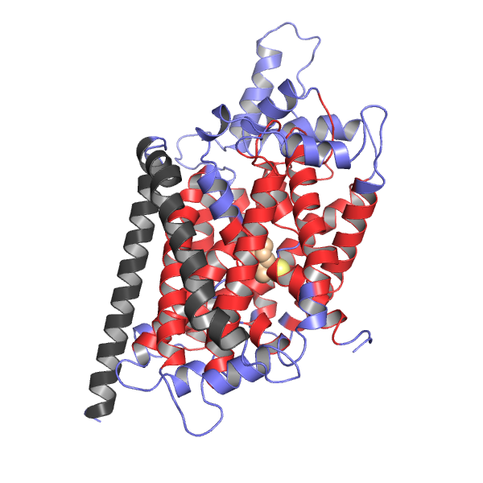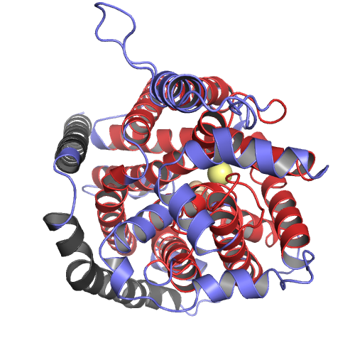
Figure S1: The symmetric inward open (SIO) model of LeuT. The inward open conformation of LeuT, as predicted by the rocking bundle model^{1,2}, was used as the target structure in PathRover a) side view and b) top view. Red regions denote constrained, unflexible regions in PathRover while blue regions denote flexible degrees of freedom. Cytosolic side is towards the bottom of the page, periplasmic side is towards the top. The leucine substrate (tan) and the internal Na⁺ ions (yellow) are shown here for clarity.
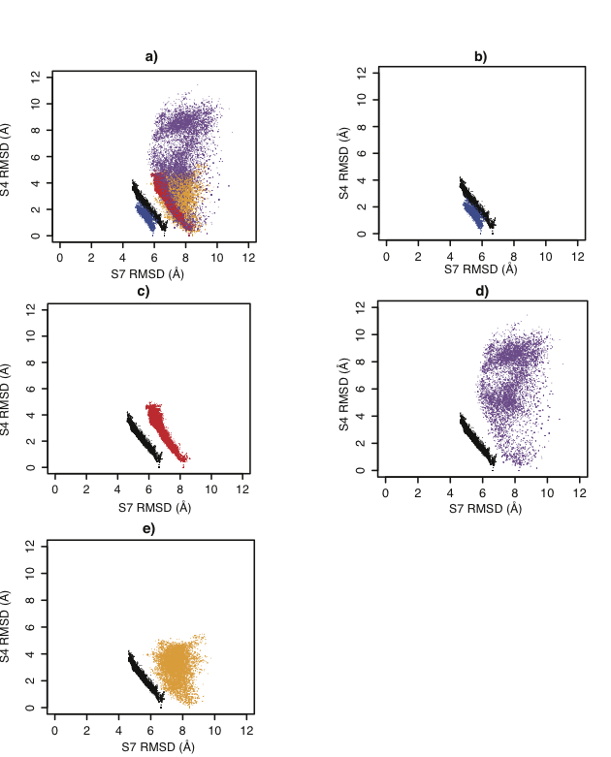
Figure S2: Decomposition of RMSD for LeuT along the S4_{LeuT} ⇔ S7_{SIO} pathway. (a) Superposition of all regions of interest; (b) TM regions in blue; (c) degrees of freedom in red; (d) extracellular loop 4 (EL4) in purple; (e) extracellular loop 2 (EL2) in yellow.
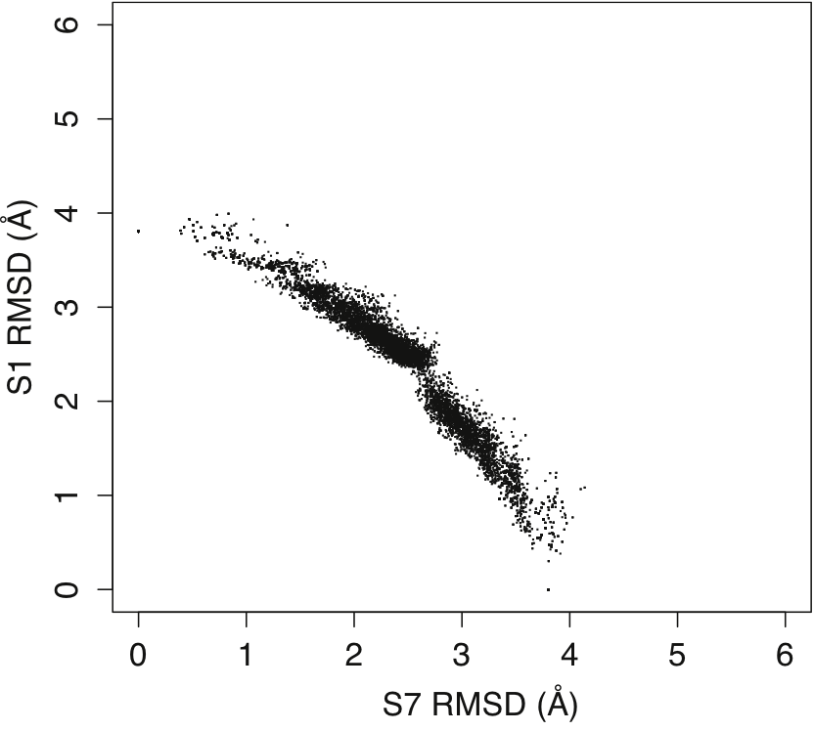
Figure S3: Computed substrate translocation pathway for a rationally designed mutant of LeuT. RMSD landscape of all Motion Planning (MP) computed conformations for S1_{LeuT-mutant} ⇔ S7_{LeuT-mutant.}

References:

(1) Forrest, L. R.; Zhang, Y.-W.; Jacobs, M. T.; Gesmonde, J.; Xie, L.; Honig, B. H.; Rudnick, G. Proceedings of the National Academy of Sciences of the United States of America 2008, 105, 10338-43.
(2) Forrest, L. R.; Rudnick, G. Physiology (Bethesda, Md.) 2009, 24, 377-86.

